--1 sa se afiseze numarul total de produse [Production].[Product]

select count(*)

from Production.Product;

--2 sa se afiseze numarul total de produse de culoare Red

select count(*)

from Production.Product

where Color='red';

--3 sa se afiseze suma totala a pretului de lista ListPrice

select sum(ListPrice)

from Production.Product;

--4 sa se afiseze media cost standard [StandardCost]

select avg(StandardCost)

from Production.Product;

--1. Selecting Data:

--Write a query to select all the columns from the Person.Person table.

select

* -- toate coloanele

from Person.Person;

--2. Filtering Data:

--Write a query to find all the persons whose first name is "Ken" from the Person.Person table.

select

*

from Person.Person

where FirstName='Ken';

--3. Ordering Data:

--Write a query to select all the columns from the Production.Product table, ordered by Name in ascending order.

select

*

from Production.Product

order by Name desc;

--4. Limiting Results:

--Write a query to select the top 5 most expensive products from the Production.Product table.

select distinct top 5 --with ties

*

from Production.Product

order by ListPrice desc;

--5. Calculations:

--Write a query to calculate the average list price of all the products in the Production.Product table.

select AVG(ListPrice) as AvgListPrice

from Production.Product;

--6. Using Aggregate Functions:

--Write a query to find the maximum, minimum, and average ListPrice from the Production.Product table.

select

MAX(ListPrice) as MaxListPrice,

MIN(ListPrice) as MinListPrice,

AVG(ListPrice) as AvgListPrice

from Production.Product;

--7. Using Aliases:

--Write a query to select the ListPrice column as Price from the Production.Product table.

select

ListPrice as Price

from Production.Product;

--8. Using DISTINCT:

--Write a query to select distinct Color values from the Production.Product table.

select distinct

Color

from Production.Product

where Color is not null

order by Color;

--9. Counting Records:

--Write a query to count the number of records in the Person.Person table.

select count(*)

from Person.Person;

**-- Learn Group By**

create database DemoDB;

use DemoDB;

create table movie(

id int primary key not null,

title varchar(100) not null,

releaseyear int null,

category varchar(100) null,

rating dec(4,2)

);

insert into movie(id, title, releaseyear,category,rating)

values (1,'The Godfather',1972,'Drama',9.2);

insert into movie(id, title, releaseyear,category,rating)

values (2,'The Dark Knight',2008,'Action',9.0);

insert into movie(id, title, releaseyear,category,rating)

values (3,'The Lord of the Rings',2003,'Action',9.0);

insert into movie(id, title, releaseyear,category,rating)

values (4,'Pulp Fiction',1994,'Drama',8.2);

insert into movie(id, title, releaseyear,category,rating)

values (5,'Fight Club',1999,'Drama',8.8);

insert into movie(id, title, releaseyear,category,rating)

values (6,'Inception',2010,'Action',8.8);

select

category, count(distinct rating)

from movie

group by category;

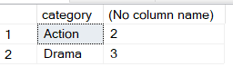

-- from Adventure get how many products are for each color:

select Color, count(*) as NmbProducts

from Production.Product

where Color is not null

group by Color

order by NmbProducts desc;

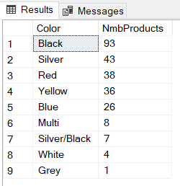

select

Color,

MIN(ListPrice) as MinListPrice,

MAX(ListPrice) as MaxListPrice,

cast(AVG(ListPrice) as decimal(10,2)) as AvgListPrice

from Production.Product

where Color is not null

group by Color;

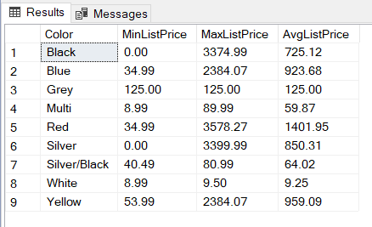

select count(*)

from Sales.SalesOrderHeader

select top 10

*

from Sales.SalesOrderHeader

-- **order date**

-- in ce an au fost cele mai multe comenzi:

select top 1

year (OrderDate), count (*) as NmbOrders

from sales.SalesOrderHeader

group by year(OrderDate)

order by NmbOrders desc

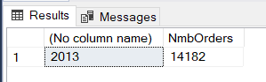

-- in ce zi a lunii au fost cele mai multe comenzi:

select top 2

day(OrderDate), count (*) as NmbOrders

from sales.SalesOrderHeader

group by day(OrderDate)

order by NmbOrders desc

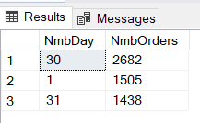

select top 1

dayorder, datename(mm,monthorder) as monthname, NmbOrders

from

(

select

day(orderdate) dayorder, month(orderdate) monthorder, count(*) as NmbOrders

from Sales.SalesOrderHeader

group by day(orderdate), month(orderdate)

) vt

order by NmbOrders desc;

